This n That

An e-mail newsletter from Agapé Athletics Club

Editor: Marieta Bortoli 082 466 7031 11 March 2019 www.agape.org.za

E-mail: marietabortoli@gmail.com

NB

- Next league race – 30 March
- Awards function 4 May
- Agapé race (Jacaranda City Challenge) – 12 October. Members to assist. PLEASE DIARIZE !!!!!!

Editorial

Please take note that our gazebo will be at the “Om die Dam” race this coming Saturday and not at the race in Pretoria.

Please remember to hand in your floating trophies if not already done.

Members staying in the Moot area please take note that the time trial at Rietondale is open again and is on a Thursday at 17h30 in North Street.

Notice Board Additions

◊ The Green Mileage (replacing the Denel race)

Attachments

□

Birthday Greetings

May your birthday bring joy, contentment and may the Lord’s blessing surround you.

Mag jy in hierdie nuwe lewensjaar ‘n innerlike vrede ken wat jou in staat sal stel om die eise en behoeftes van elke dag in die seker wete van die Heer se teenwoordigheid tegemoet te gaan.

Eddie Howden 09 March | Marius van der Westhuizen 17 March
Annalie du Plessis 18 March | Johnathan Nordenden 22 March

Personalia

Welcome new and former members

In the mailbox

General
Clothing available:
Buffs @ R100
Ladies skirts @ R200
Second skins @ R220
Age tags @ R30

The items will also be available at races, please visit our gazebo or contact Marix at 072 541 7268

Congratulations

Congratulations to the following members:

Martie Boesemberg who achieved her permanent race number at the Kosmos 3-in-1 race.

Thank you’s

Race reports

Race Results

League results

Training/Health snippets
JUST HOW CRUCIAL IS A GOOD NIGHT’S SLEEP BEFORE A MAJOR EVENT
Anxiety causes many athletes to sleep poorly the night before a major competition, and if they have crossed more than a couple of time zones in order to compete, actual sleep may be limited to just an hour or two. Some elite athletes claim that they have set personal bests after a night of tossing and turning, but the prevailing view is that poor sleep tends to lead to poor performances. What is the true effect of sleepless nights on competitive capacity, and should athletes worry if they chalk up only an hour or two of sleep the night before a major event?
One problem in working out how sleep deprivation influences exercise capacity is that scientists don’t completely understand sleep itself. It is clear, however, that sleep can be divided into five distinct stages: stages 1-4 consist of non-rapid-eye-movement sleep; during a normal night of sleep, these are usually followed by the rapid-eye-movement (REM) stage of sleeping (stage 5). Scientists who specialise in sleep maintain that during a night of normal sleep, REM and non-REM sleep stages repeat in cycles lasting about one-and-a-half hours, although age and the amount and quality of sleep on previous nights can alter this pattern.
Since stages 3 and 4 of sleep produce brain waves which have a slow frequency, these stages are referred to as ‘slow-wave’ sleep. As it happens, slow-wave sleep is critically important for athletes, because it is when growth hormone is released from the pituitary gland at the base of the brain. Growth hormone stimulates muscle growth and repair, bone building and fat burning; it is thus one of the key hormones which help athletes recover from tough workouts and also improve physiologically in response to training. Studies show that when an athlete loses sleep (particularly slow-wave sleep), growth-hormone release from the pituitary gland diminishes. This may be a key reason why extended sleep loss can lead to decrements in physical capacity.
The physical and mental effects of missing out on sleep but how much sleep do you actually have to miss in order to degrade your ability to lift weights, diminish your pedal-pushing power or slow your swimming speed significantly? Research reveals that as little as 20 hours of sleep deprivation can impair mental performance, but the amount of sleep loss required to damage physical prowess is less certain. What is known is rather startling, suggesting, as it does, that the physical functioning of the human body is relatively unaffected by sleep loss.
For example, after a total of 60 consecutive hours without sleep, many individuals find short, intense workouts no harder than usual. After 30 hours of sleep deprivation, athletes doing long workouts consume oxygen at the same rate, with heart rates that may actually be lower than usual, although they feel sleepy and fatigued and may report that the training session feels harder.
Nonetheless, lack of sleep can have a negative impact on performance. Studies show that going 36 hours without sleep can decrease an athlete’s time to exhaustion (how long he or she can sustain a particular intensity of exercise without stopping) by an average of about 10-11% at a moderately hard intensity of about 80% VO2max (87% of maximal heart rate). However, a notable aspect of this research is that there is tremendous variability among individuals. Some athletes display large losses in performance (15% or more), others decline in capacity by much smaller amounts (less than 5%), while a few actually perform better when they are sleep-deprived!
Some of the research on sleep loss and performance has been a bit contradictory. For example, one investigation showed that sleep loss diminished the ability to produce peak power while exercising (i.e. when sprinting for home at the end of a race, accelerating up hills while cycling, or churning the water during a 200m swim event), in part by lowering maximal heart rate. Other research has shown that sleep loss can reduce coordination and efficiency during exercise (remember that only 20 hours without sleep is enough to impair normal mental functioning, which could lead to less efficient control of the muscles by the nervous system). Not surprisingly, vertical jumping ability and isokinetic strength tend to deteriorate with sleep deprivation.
However, studies show that in spite of these negative effects, sleep deprivation extending as long as 64 hours does not necessarily damage 100m dash performance, nor decrease isometric muscle strength. The other good news is that most athletes do not actually stay awake for 30-60 consecutive hours, which is the kind of sleep deprivation most closely linked with losses in physical performance. It’s much more common for anxious or time-zone-challenged athletes to get a little sleep – even if it is only 2-3 hours – during the night (or nights) before important events. And scientific research relating to sleep patterns like this is actually very reassuring. For example, studies show that if an athlete sleeps only 2.5 hours per night for three consecutive nights, there is absolutely no loss in hand and arm-muscle strength, no decrease in broad jumping ability, no increase in perceived exertion during strenuous exercise, no decline in lung function or respiratory capacity, and – most importantly – no loss of endurance capacity. It is true that total anaerobic capacity may decline a little in such circumstances, which would have the strongest impact on athletes taking part in continuous competitive events lasting four or five minutes, or less. The loss is actually fairly small, but even a few hundredths of a second can make a significant difference to how an athlete places in a very competitive race. In other words, limited sleep can have a small but important effect on high-intensity performance.
Scientists have found that body temperature is strongly influenced by sleep loss. Sleep deprivation tends to lower resting body temperature, which explains why individuals often feel cold after a sleepless night or several nights of poor sleep. Although sleeplessness tends to keep the body cool, body temperature actually rises faster during exercise when athletes are sleep-deprived. Thus, loss of sleep might increase the risk of heat illness when exercising on hot and/or humid days.
The good news is that research indicates that the problem most often experienced by athletes – just one night of almost total sleeplessness before a major event – is unlikely to hurt performance. True, if you think you will perform more poorly after such a night, you probably will, but the point is that there is no real reason for you to think that way! The scientific evidence suggests that you’ll still have a great chance to achieve your best-ever performance – even if you have just set a personal record for tossing and turning in bed the night before your big event.

Your thought for the week

“Change will not come if we wait for some other person or some other time. We are the ones we’ve been waiting for. We are the change that we seek”.

Your smile for the week

A man went to his lawyer and told him, "My neighbour owes me R500 and he won’t pay up. What should I do?" "Do you have any proof he owes you the money?" asked the lawyer. "Nope," replied the man. "OK, then write him a letter asking him for the R5,000 he owed you," said the lawyer. "But it's only R500," replied the man. "Precisely. That’s what he will reply and then you’ll have your proof!"

==

Pappu: My internet is not working properly
Officer: Ok, Double click on “My computer”
Pappu: I can’t see ur computer…
Officer: No no… click on “My computer” on ur computer…
Pappu: How can I click on ur computer from my computer?
Officer: Listen… There is an icon labelled “My Computer” on ur computer… Ok. double click on it..
Pappu: What the hell, what is your computer doing on my computer..???
Officer: Double click on ur computer..
Pappu: On which Icon I’ve to click..
Officer :“My Computer”..
Pappu:…Oh u Idiot…… Tell me where is ur office…I’ll come there and click on ur “Computer”.

Something to ponder over / something spiritual
The Train
Life is like a journey on a train... with its stations... with changes of routes... and with accidents! At birth, we boarded the train and met our parents. We believe they will always travel on our side. However, at some station, our parents will step down from the train, leaving us on this journey alone.
As time goes by, other people will board the train; and they will be significant: our siblings, friends, children, and may be the love of our life. Many will step down and leave a permanent vacuum. Others will go so unnoticed that we don't realize that they vacated their seats!
This train ride will be full of joy, sorrow, fantasy, expectations, hellos, goodbyes, and farewells. Success consists of having a good relationship with all the passengers...requiring that we give the best of ourselves.
The mystery to everyone is:
We do not know at which station we ourselves will step down. So, we must live in the best way - love, forgive, and offer the best of who we are. It is important to do this because when the time comes for us to step down and leave our seat empty -- we should leave behind beautiful memories for those who will continue to travel on the train of life.
I wish you a joyful journey on the train of life.
Reap success and give lots of love. More importantly, thank God for the journey!
Cancelled Races

Denel Road Race scheduled for 23 March

Notice Board

Useful Links:
www.raceresults.co.za/flyers - for the latest race pamphlets
www.agn.co.za/#League for the latest league logs and the league points you earned

Saturday 16 March Om-Die-Dorp Road Race 21.1/10/5 km
Race Organisers: Wingate Road Runners
Venue: PvR Community Church, Baltimore Avenue, Pierre van Ryneveld

 | 21.1 km | 10 km | 5 km
Entry fee | R 90 | R 70 | R 50
Start Time | 06:00 |  | 06:15
Cut-off | 03:30
No Pets

No iPods or listening devices are allowed

Pre-entries at: Run-away Sport; Sweatshop Southdowns

www.enteronline.co.za

21.1km Championships
Thursday 21 March Right to Run/Walk 21.1/10/5 km
Race Organisers: Arcadia Running Club
Venue: Sunnypark Shopping Centre, c/o Steve Biko- & Robert Sobukwe Streets, Sunnyside
GPS: S 25 45’2 E 28 12’11

 | 21.1 km | 10 km | 5 km
Entry fee | R 100 | R 80 | R 50
Start Time | 07:00
Cut-off | ??
No Pets

No iPods or listening devices are allowed

Pre-entries at: Run-away Sport; Sweatshop Southdowns: Cross Trainer Sunnypark; Sports Scene Sunnypark; Tshwane Running Shop

www.entrytime.com

Saturday 23 March The Green Mileage 16/8/4 mile
Race Organisers: ?
Venue: Sportspark Complex, Lyttelton, Centurion
GPS: S 25.82522 E 28.20769

 | 16 miles | 8 miles | 4 miles
Entry fee | R 120 | R 80 | R 50
Start Time | 06:00 |  | 06:10
Cut-off | 04:00

There is also a kiddie’s race of ½ a mile @ R20 starting at 06:20

No Pets

No iPods or listening devices are allowed

Pre-entries at: Run-away Sport; Sweatshop Southdowns

www.bouttime.com

LEAGUE RACE
Saturday 30 March Kolonnade Road Race 32/15/5 km
Race Organisers: Overkruin Athletics Club
Venue: Kolonnade Shopping Centre, c/o Sefako Makgatho Drive & Dr van der Merwe Street, Montana

 | 32 km | 15 km | 5 km
Entry fee | R 110 | R 90 | R 40
Entre fee 60+ (Race day only & proof of age) | Free
Start Time | 06:00 |  | 06:15
Cut-off | 04:00 | 03:00

No Pets

No iPods or listening devices are allowed

Pre-entries at: Run-away Sport; Sweat Shop Irene; Tshwane Running Shop; Kolonnade Info Desk

www.entrytime.co.za

2019 AGN LEAGUE FIXTURE LIST
EVENT | DISTANCE | DATE | LEAGUE
 |  |  | RR | RW
Kolonnade Road Race | 32/15 km | 30/03/19 | X | X
Run Against Drugs | 21.1/10 km | 13/04/19 | X | X
Skosana Development Run | 21.1/10 km | 25/05/19 | X | X
Race of Friendship | 21.1/10 km | 29/06/19 | X | X
Zwartkop Road Race | 21.1/10 km | 27/07/19 | X | X
Spirit of Flight | 10 km | 31/08/19 | X | X
Brooklyn Road Race | 21.1/10 km | 07/09/19 | X | X
Capital Classic | 21.1/10 km | 05/10/19 | X | X
Freedom of Expression | 21.1/10 km | 02/11/19 | X | X

Masters Athletics Fixture list

South Africa
22/23 March 2019 KZN Kings Park Stadium
29/30 March 2019 PE Westbourne Oval
29/30 March GNMA Pilditch
13 April 2019 WP Cape Town
13 April 2019 CGMA Herman Immelman
10 August 2019 Mpumalanga Secunda
? October 2019 Rassies Bronkhorstspruit
25/26 October 2019 SWD Oudtshoorn
8/9 November 2019 Free State Bloemfontein

South African Championships
2/3/4 May 2019 SWD Oudtshoorn
April/May 2020 Central Gauteng Herman Immelman

Africa Championships
2021 Nairobi, Kenya
2023 South Africa

International Championships
24-30 March 2019 WMA Indoor Torun, Poland
28/9-6/10 2019 30th Summer universiade Naples, Italy
20/7/2020 – 1/8/2020 World Masters athletics Champs Toronto, Canada

Time Trials:

Centurion - Wednesdays at 17:30
Lewende Woord Centurion
Contact Marinda 654 5800 (h) / 082 720 9017

Zita Park - Tuesdays at 17:30
Zita Street, Zita Park, Garsfontein
Contact Hennie Venter – 082 676 6792

Gazebo Enquiries

Hennie Venter – 082 676 6792

INTERCESSOR

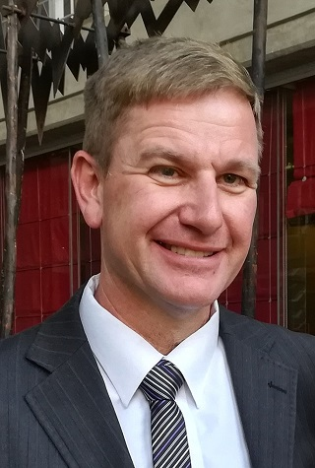

Jaco Barkhuizen 083 519 1737

Agapé Executive 2018/2019

Name | Position | Telephone number | E-mail address
Hennie Venter | Chairperson | 082 676 6792 | henniev@seng.co.za  venterhennie08@gmail.com
Hennie Venter | Registrar & Club Captain | 082 676 6792 | henniev@seng.co.za  venterhennie08@gmail.com
Marieta Bortoli | Treasurer & Vice chairperson | 082 466 7031 | marietabortoli@gmail.com
Marieta Bortoli | Secretary & Editor | 082 466 7031 | marietabortoli@gmail.com
De Wet de Beer | Race organizer & PRO | 082 373 2987 | dewet@styletechnique.co.za
Jaco Barkhuizen | Intercessor | 083 519 1737 | jaco00028@gmail.com
Marix Venter | Clothing co-ordinator | 072 541 7268 | ventermarix9@gmail.com
Marix Venter | General activities | 072 541 7268 | ventermarix9@gmail.com
Gustav Brink | Statistician | 083 417 8431 | gustav.brink@gmail.com

Agapé Executive

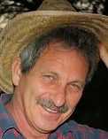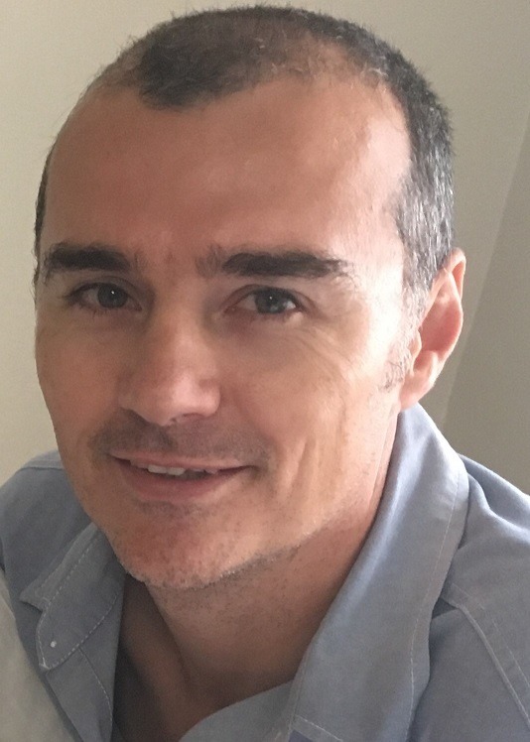
Hennie Venter Marieta Bortoli De Wet de Beer

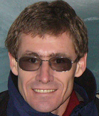
Jaco Barkhuizen Marix Venter Gustav Brink (Ex-officio)

